# Project Charter: GA4 Anomaly Detection Platform Deployment

**Date:** January 19, 2026

## 1. Executive Summary

A high-level snapshot of the three-week project lifecycle, from initial assignment to final delivery.

| **Role** | **Who** | **Start Date** | **End Date** |
| --- | --- | --- | --- |
| **Responsible (Owner)** | Ronit Rajput | 2026-01-13 | 2026-01-30 |
| **Involved (Team)** | Vishnu Nair, Aarya Samaiya, Dhananjay Kanjariya | 2026-01-13 | 2026-01-30 |

## 2. Purpose

### 2.1 Project Background (The "Why")

Organizations currently rely on manual checks for GA4 data quality, which is inconsistent and slow. Critical metric drops (revenue/conversions) often go unnoticed, leading to significant financial loss and a breakdown in data trust. The goal is to move from reactive manual monitoring to proactive automated detection.

### 2.2 Project Objective (The "Goal")

Deploy a productized GA4 Anomaly Detection solution using BigQuery ML (ARIMA_PLUS) to achieve **≥90% detection accuracy** for high-severity anomalies by the January 30th deadline.

### 2.3 Customer Benefit (The "Value")

The Analytics and Marketing teams will save an estimated **10-15 hours per week** previously spent on manual data investigation, allowing them to focus on optimization rather than troubleshooting.

## 3. Work Breakdown Structure (WBS) & Timeline

| **WBS ID** | **Task/Milestone Name** | **Task Type** | **Dependency** | **Responsible** | **Resources Required** | **Start Date** | **End Date** | **Deliverable** | **Status** |
| --- | --- | --- | --- | --- | --- | --- | --- | --- | --- |
| **1.0** | **MILESTONE: Project Assignment** | Sequential | - | Ronit Rajput | Assignment Brief | 2026-01-13 | 2026-01-13 | Assigned Project Ops | ✅ |
| 1.1 | Initial Planning & Scoping | Sequential | 1.0 | Ronit Rajput | Technical Framework | 2026-01-13 | 2026-01-16 | Preliminary Scope Doc | ✅ |
| 1.2 | Define Business Success Metrics | Sequential | 1.1 | Vishnu Nair | Framework PDF | 2026-01-16 | 2026-01-18 | Metric Definition Doc | ✅ |
| **1.3** | **MILESTONE: Charter Review** | Sequential | 1.2 | Ronit Rajput | Charter Draft | 2026-01-19 | 2026-01-19 | Approved Project Charter | ✅ |
| **2.0** | **MILESTONE: Data Ready for ML** | Sequential | 1.3 | Aarya Samaiya | GA4 Admin & API Access | 2026-01-20 | 2026-01-20 | Confirmed BQ & API Connectivity | ✅ |
| 2.1 | Map GA4 Event/API Schemas | Sequential | 2.0 | Aarya Samaiya | BQ Dataset & API Credentials | 2026-01-20 | 2026-01-21 | Schema Mapping Doc | ✅ |
| 2.2 | Build BQ Preprocessing Scripts | Sequential | 2.1 | Dhananjay Kanjariya | BigQuery SQL Editor | 2026-01-21 | 2026-01-22 | SQL Views/Stored Procs | ✅ |
| 2.3 | Validate Backfill Data Quality | Sequential | 2.2 | Vishnu Nair | 90-day GA4 History | 2026-01-22 | 2026-01-23 | Data Health Report | ✅ |
| **3.0** | **MILESTONE: Model & Alerting Live** | Sequential | 2.3 | Ronit Rajput | BQ ML (ARIMA_PLUS) | 2026-01-26 | 2026-01-26 | Live Notification Service | ✅ |
| 3.1 | Configure ARIMA_PLUS Forecasting | Sequential | 3.0 | Ronit Rajput | Cleaned Time-Series Data | 2026-01-26 | 2026-01-27 | Trained BQML Models | ✅ |
| 3.2 | Script Anomaly Severity Scoring | Sequential | 3.1 | Vishnu Nair | Severity Logic Framework | 2026-01-27 | 2026-01-28 | Scoring SQL Scripts | ✅ |
| 3.3 | Integrate Webhook Notification | Sequential | 3.2 | Dhananjay Kanjariya | Slack/Email API Keys | 2026-01-28 | 2026-01-29 | Deployed Alerting Logic | ✅ |
| **4.0** | **MILESTONE: Final Project Delivery** | Sequential | 3.3 | Ronit Rajput | Acceptance Template | 2026-01-30 | 2026-01-30 | Handover Documentation | ✅ |
| 4.1 | User Acceptance Testing (UAT) | Sequential | 4.0 | Vishnu Nair | UAT Environment | 2026-01-30 | 2026-01-30 | UAT Sign-off Report | ✅ |
| 4.2 | Project Closure & Review | Parallel | 4.1 | Ronit Rajput | Team Feedback | 2026-01-30 | 2026-01-30 | Lessons Learned Log | ✅ |

## 4. Project Details

### 4.1 Scope (In vs. Out)

* **Geography:** Global (Single GA4 Property).
* **Functionality:** P0 (BQ Export) & P1 (GA4 Data API) Paths. Direct BQ ML execution.
* **Users:** Analytics Team and Marketing Stakeholders.
* **Out of Scope:** External orchestration tools (Dataform/Airflow) and multi-property blending.

### 4.2 Budget & Cost Justification (INR Breakdown)

| **Category** | **Item** | **Total (INR)** | **Cost Justification** |
| --- | --- | --- | --- |
| **Set-up** | BigQuery Storage & Slots | ₹12,450 | Scanning 90 days of raw GA4 historical events for baseline creation. |
| **ML Dev** | BigQuery ML Training | ₹16,600 | Compute cost for native ARIMA_PLUS training cycles in BigQuery. |
| **Alerting** | GCP Cloud Functions | ₹8,300 | Execution costs for API-based webhook triggers to Slack/Teams. |
| **Buffer** | Technical Contingency | ₹4,150 | ~10% buffer for unexpected query volume or model re-training. |
| **TOTAL** |  | **₹41,500** |  |

**ZERO COST** **Justification**

1. **BigQuery Limits:** You get 10 GB of storage and 1 TB of query processing per month for free. Since Aarya is scanning 90 days of historical data, Dhananjay will need to write highly optimized SQL to stay under that 1 TB limit.
2. **BigQuery ML (ARIMA_PLUS):** Google usually offers the first 10 GB of ML model training per month for free. Ronit will need to ensure the training data is filtered to only the essential metrics to avoid crossing into paid territory.
3. **Cloud Functions:** The first 2 million invocations per month are free, which is plenty for your alerting needs.
4. **No Sandbox Project:** We would have to perform all work in the production environment (carefully) since a separate "Sandbox" project might incur extra costs if not managed within the free tier limits.

### 4.3 Technical Stack (The "Tech Stack")

| **Layer** | **Component** | **Functional Specification** |
| --- | --- | --- |
| **Data Collection** | **GA4 BQ Export & GA4 Data API** | Event-level data (P0) and aggregate metrics via API (P1 fallback) |
| **Data Warehouse** | **Google BigQuery** | Primary storage & native SQL orchestration (Managed by Ronit/Dhananjay) |
| **ML Engine** | **BigQuery ML** | ARIMA_PLUS for time-series, seasonal, and holiday forecasting |
| **Alerting Engine** | **GCP Cloud Functions** | Python/Node environment to trigger Slack/Teams/Email webhooks |
| **Notification** | **Pub/Sub** | Messaging layer for fault-tolerant alert delivery |

### 4.4 Resources (Team)

* **Ronit Rajput (Owner):** Lead Data Scientist & ML Model Configuration.
* **Vishnu Nair:** Lead Data Analysis, Insights, & Severity Scoring.
* **Aarya Samaiya:** Lead Data Collection (BigQuery & API) & Schema Mapping.
* **Dhananjay Kanjariya:** BQ Automation, SQL Scripting, & Alerting Integration.

### 4.5 Risks & Mitigation

* **Risk:** GA4 API quota limits or service availability. *Mitigation:* Aarya to monitor daily quota usage and prioritize BQ export where possible.
* **Risk:** SQL Query costs exceeding budget. *Mitigation:* Dhananjay to perform query optimization/dry runs.

## 5. RACI Chart (Roles & Responsibilities)

| **Deliverable / Task** | **Ronit Rajput** | **Vishnu Nair** | **Aarya Samaiya** | **Dhananjay K** |
| --- | --- | --- | --- | --- |
| Project Charter & Plan | **R/A** | **C** | **I** | **I** |
| GA4 to BQ & API Setup | **I** | **C** | **R/A** | **C** |
| BQ SQL Scripting & Views | **A** | **C** | **C** | **R** |
| ARIMA_PLUS Model Training | **R/A** | **C** | **I** | **C** |
| Severity Scoring Logic | **I** | **R/A** | **I** | **I** |
| Alert Webhook Integration | **A** | **I** | **I** | **R** |

## 6. Communication Plan

* **Daily Stand-up:** 15-min Slack sync @ 9:30 AM led by Ronit.
* **Status Update:** Weekly email to stakeholders every Friday by 4:00 PM.

## 7. Final Success Measurement

### 7.1 Primary Objectives

The success of this project is measured by the platform's ability to:

1. **Detect Anomalies**: Identify statistically and contextually significant anomalies in GA4 data.
2. **Classify Impact**: Successfully categorize anomalies by business impact and root cause likelihood.
3. **Actionable Alerts**: Provide alerts that are both explainable and immediately actionable for stakeholders.

### 7.2 Success KPIs

| **Category** | **KPI** | **Success Target** |
| --- | --- | --- |
| **Product** | Precision / Recall | ≥90% accuracy in anomaly detection (ARIMA_PLUS Confidence) |
| **Product** | False Positive Rate | <10% verified false triggers (Tuned by Ronit Rajput) |
| **Product** | Alert Acknowledgment Rate | 100% of P0 severity alerts acknowledged by Marketing |
| **Business** | Revenue Blind Spots | ≥50% reduction in revenue-impacting data blind spots |
| **Business** | Investigation Time | ≥75% reduction in manual investigative time for Vishnu Nair |

### 7.3 Acceptance Criteria (Definition of "Done")

Final project sign-off on January 30, 2026, is contingent on the following:

* **Detection Coverage**: Anomalies successfully detected across all predefined metric sets (Conversions, Revenue, Engagement).
* **Baseline Accuracy**: Native industry-aware baselines applied and verified for seasonality.
* **Validation**: All alerts and automated explanations validated by Subject Matter Experts (SMEs) and formally signed off by **Vishnu Nair**.

### Technical Architecture:

<https://drive.google.com/file/d/1e5AgV3-ADN9nwADTmWVg8-1ON7VLWWDG/view?usp=drive_link>

### Layers:

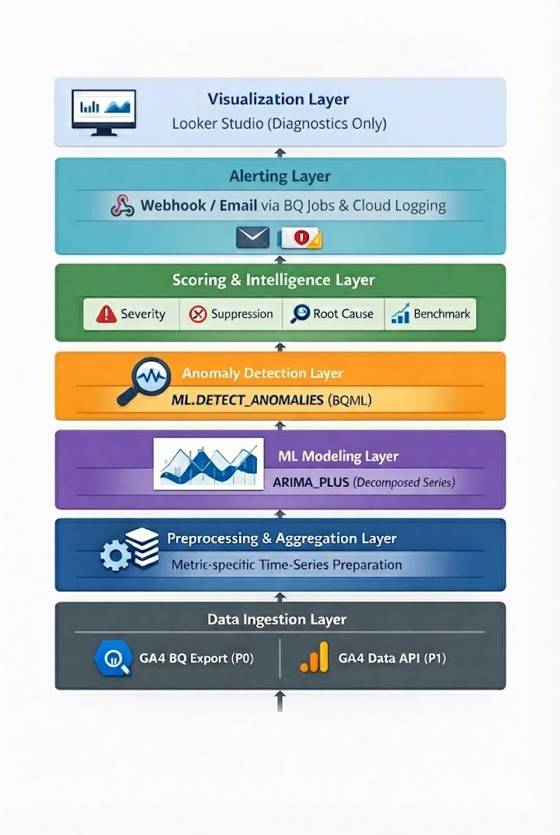

**Gantt Chart:**

